Lab 3
Supplier
SupplierID (PK) | Name | Address
S01 | ABC Company | KL
S02 | XYZ Company | PJ
S03 | HJK Company | PJ
S04 | PQR Company | JB

Primary key: SupplierID

Product
ProductID (PK) | Name | Price | Quantity
P01 | Keyboard | 80 | 60
P02 | Mouse | 30 | 70
P03 | Monitor | 200 | 80
P04 | Pendrive | 40 | 50

Primary key: ProductID

Supplies
SuppliesID | SupplierID (FK) | ProductID (FK) | Date | Quantity
001 | S01 | P01 | 1/ 1/17 | 100
002 | S01 | P02 | 2/2/2017 | 200
003 | S01 | P03 | 2 /3/2017 | 300
004 | S02 | P03 | 3/4/2017 | 400

Primary key: SuppliesID
Foreign Key: SupplierID, ProductID

- Using Ms SQL Server, create a new database Lab3
- Write query to create the tables given above

- Write query to add each row of data into the tables

Attributes | Data Type
SupplierID | nvarchar(50)
Name | nvarchar(50)
Address | nvarchar(50)

Attributes | Data Type
ProductID | nvarchar(50)
Name | nvarchar(50)
Price | integer
Quantity | integer

Attributes | Data Type
SuppliesID | nvarchar(50)
SupplierID | nvarchar(50)
ProductID | nvarchar(50)
Date | date
Quantity | integer

Create database Lab_3
Create table Supplier(
Supplier_ID nvarchar(50) not null Primary Key,
Name nvarchar(50),
Address nvarchar(50));

Create table Product(
Product_ID nvarchar(50) not null Primary Key,
Name nvarchar(50),
Price int,
Quantity int);

Create table Supplies(
Supplies_ID nvarchar(50) Primary Key,
Supplier_ID nvarchar(50) Foreign Key references Supplier(Supplier_ID),
Product_ID nvarchar(50) Foreign key references Product(Product_ID),
Date Date,
Quantity int);

Insert into Supplier values
('S01','ABC Company','KL'),
('S02','XYZ Company','PJ'),
('S03','HJK Company','PJ'),
('S04','PQR Company','JB');

Insert into Product values
('P01','Keyboard','80','60'),
('P02','Mouse','30','70'),
('P03','Monitor','200','80'),
('P04','Pendrive','40','50');

Insert into Supplies values
('001','S01','P01','1/1/2017','100'),
('002','S01','P02','2/2/2017','200'),
('003','S01','P03','2/3/2017','300'),
('004','S02','P03','3/4/2017','400');

Reference:
https://www.w3schools.com/sql/default.asp

- Generate the database diagram
Execute this statement first (if you’re using lab PC):
Alter Authorization on Database::Lab3 To [sa];
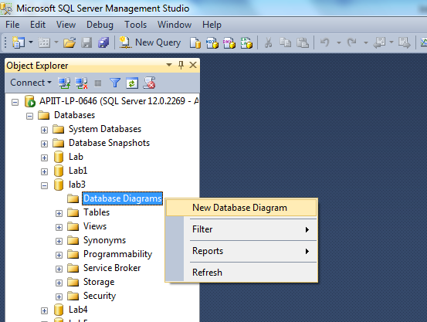

Completion:

/*
Create database Lab_3

Create table Supplier(
Supplier_ID nvarchar(50) not null Primary Key,
Name nvarchar(50),
Address nvarchar(50));

Create table Product(
Product_ID nvarchar(50) not null Primary Key,
Name nvarchar(50),
Price int,
Quantity int);

Create table Supplies(
Supplies_ID nvarchar(50) Primary Key,
Supplier_ID nvarchar(50) Foreign Key references Supplier(Supplier_ID),
Product_ID nvarchar(50) Foreign key references Product(Product_ID),
Date Date,
Quantity int);

Insert into Supplier values
('S01','ABC Company','KL'),
('S02','XYZ Company','PJ'),
('S03','HJK Company','PJ'),
('S04','PQR Company','JB');

Insert into Product values
('P01','Keyboard','80','60'),
('P02','Mouse','30','70'),
('P03','Monitor','200','80'),
('P04','Pendrive','40','50');

Insert into Supplies values
('001','S01','P01','1/1/2017','100'),
('002','S01','P02','2/2/2017','200'),
('003','S01','P03','2/3/2017','300'),
('004','S02','P03','3/4/2017','400');
*/

